CITI Training – Good Clinical Practices
- Open the CITI website by going to www.citiprogram.org
- Login to the site to begin training
  - New Users - Click on the link “Register Here” to setup a new CITI user account.
  - Existing Users - Type in your Username and Password and click submit

NOTE: CITI is a third party vendor that Pennington uses for some training. Users are required to setup a username and password to complete and track their training. The username and password you select does not have to be the same as your Pennington username and password, but it does make it easier for you to remember.

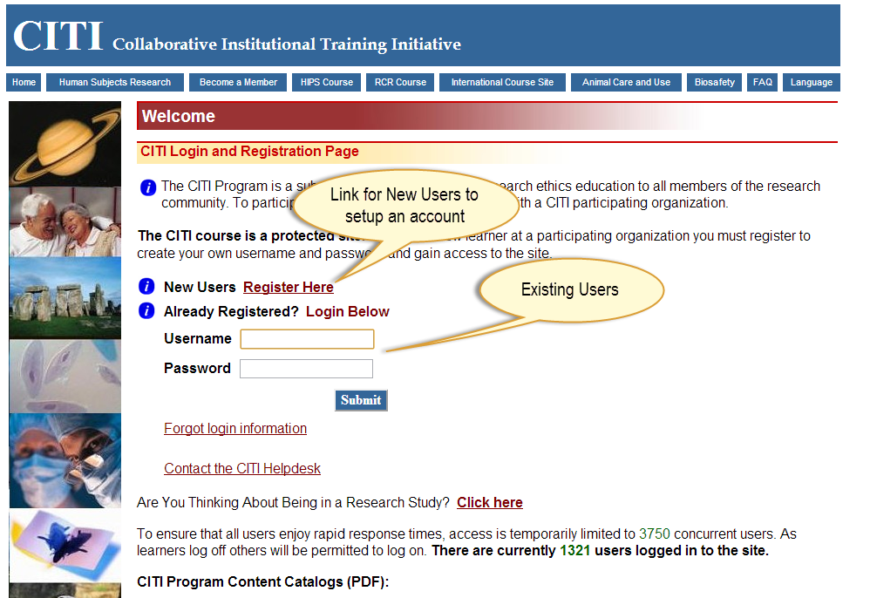

- Once logged in, you will see the following screen. It will show the list of currently assigned courses and their status.
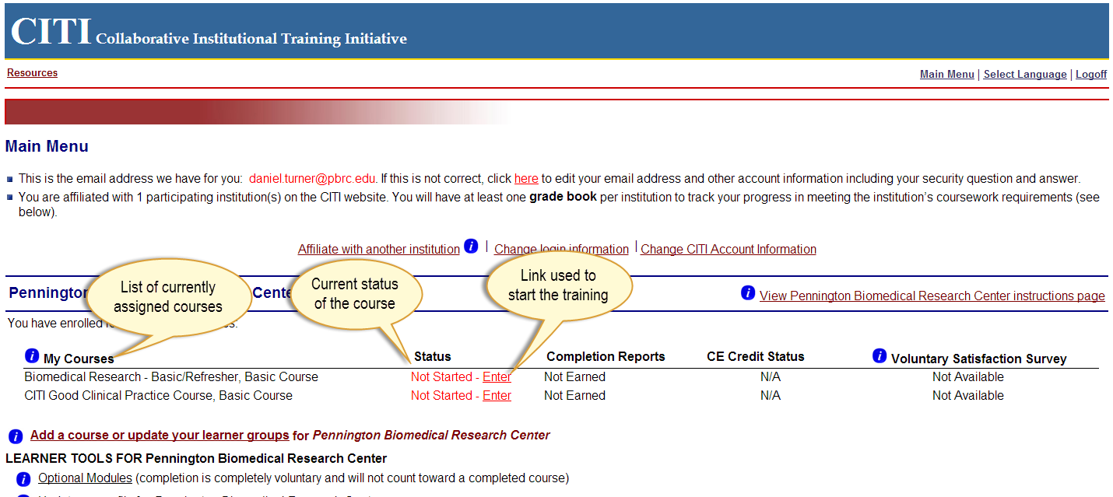

- If the Biomedical Research – Basic Refresher or CITI Good Clinical Practice Course is not listed in “My Courses” then follow the instructions listed below:
  - Click the link to “Add a course or update your learner groups”
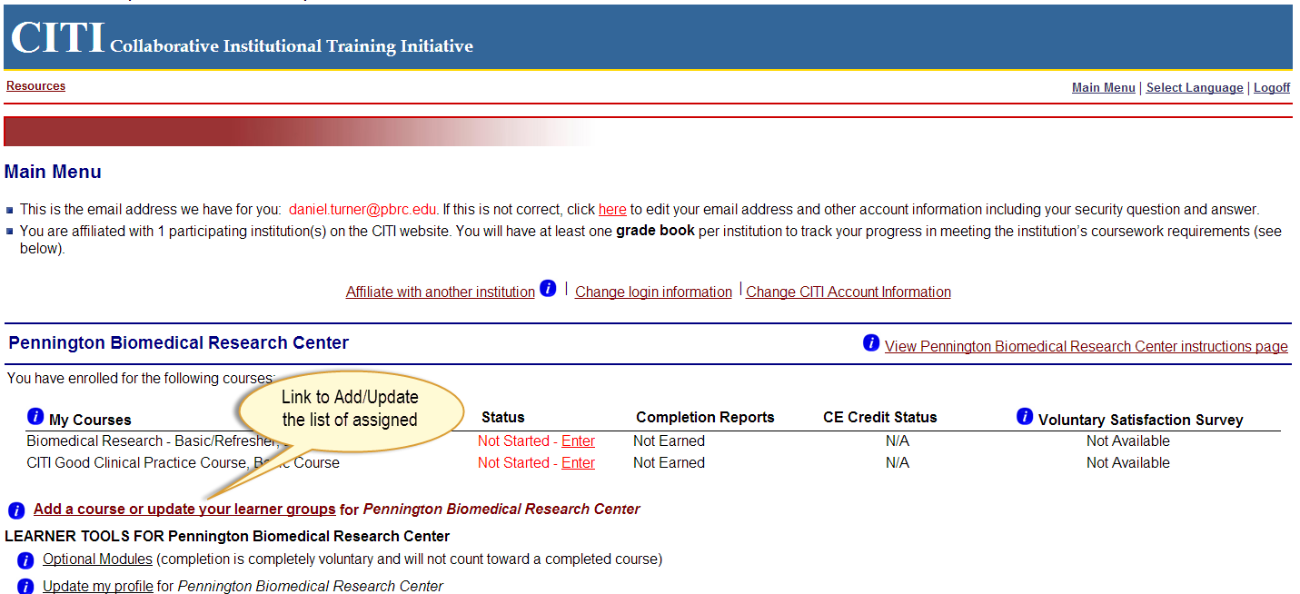

  - The next screen will provide three choices to help determine the type of training to be assigned
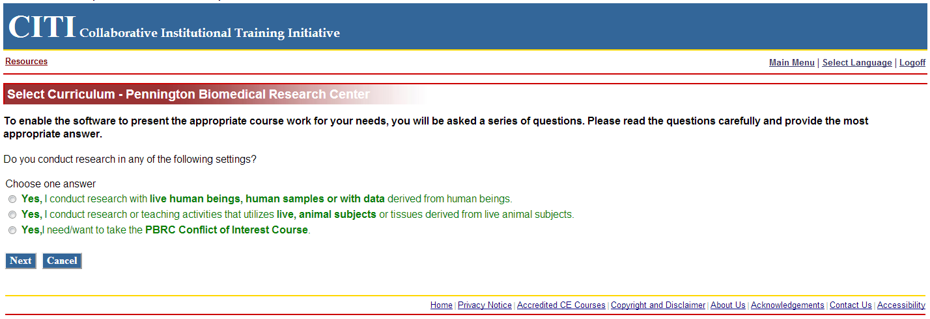

  - Select the line that deals with “live human beings…” and then click next

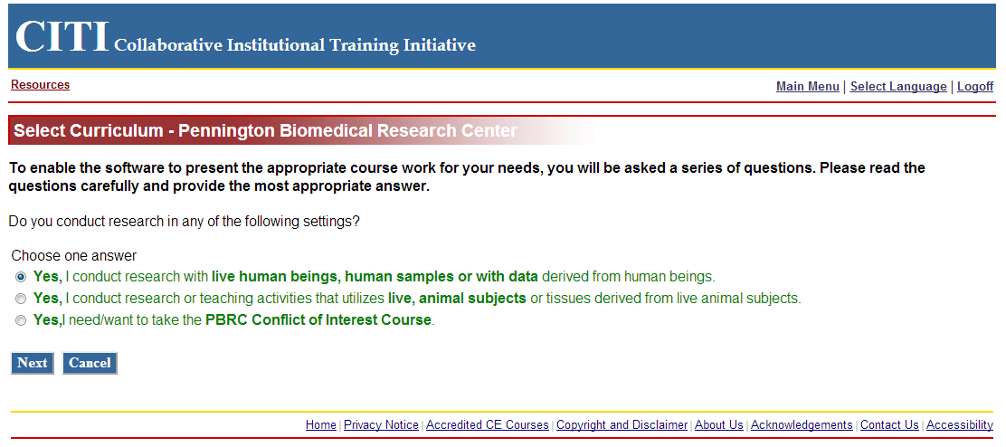

  - Please choose “Biomedical Research Investigators” and click Next.

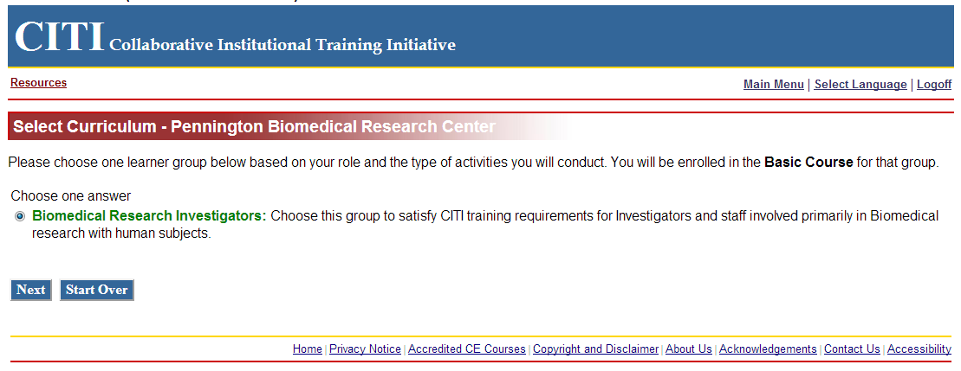

  - Select “Good Clinical Practice (GCP) and click Next.

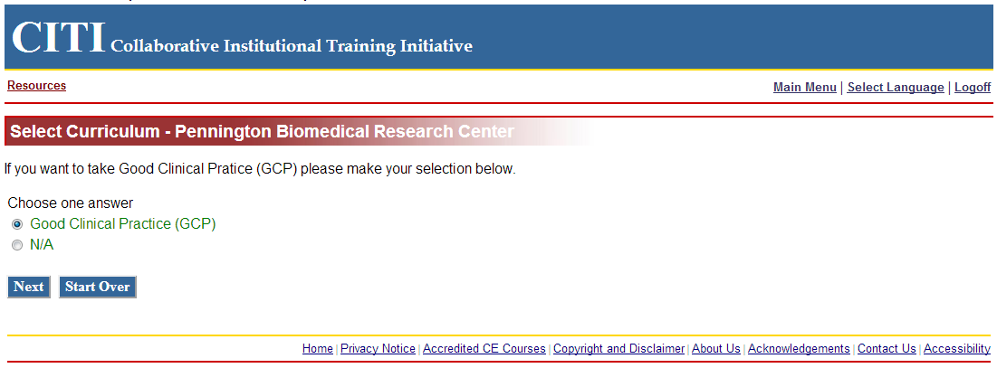

  - After clicking “Next” you should be presented with the following screen to begin training.

