CITI Instructions

General Instructions

- Go to www.citiprogram.org to register or sign in.
- Once there, if you are a new user, click on “Register”.
- If a returning user, please enter your Username and Password
- Once you log in, you will see the screen listing “Pennington Biomedical Research Center Courses”.
- Click on “Add a course or update your learner group for Pennington Biomedical Research Center”.

Instructions for Financial Conflict of Interest (FCOI) and Good Clinical Practice (GCP) Training

- In order to satisfy the Financial Conflict of Interest training requirements: choose, “Yes, I need/want to take the PBRC Conflict of Interest Course” and click Next to continue on to the course.
- In order to satisfy the Good Clinical Practices requirement: choose “Yes, I conduct research with live human beings, human samples or with data derived from human beings”
- Click Next.

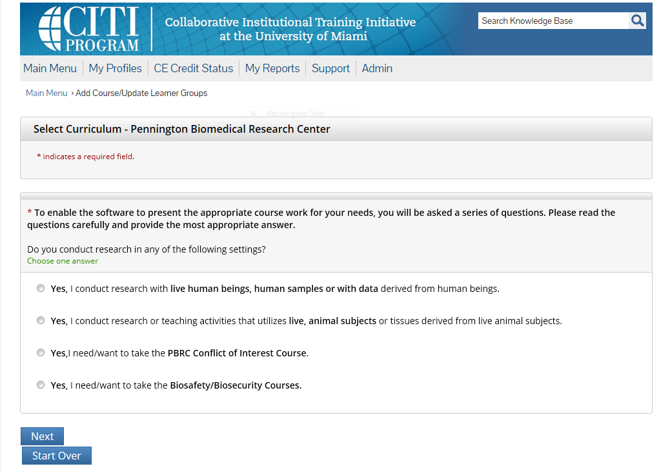

- Please choose “Biomedical Research Investigators” if you are participating in the conduct of research with human subjects OR choose “Institutional/Signatory Official” if you are the Institutional official over human subjects research.
- Click Next.

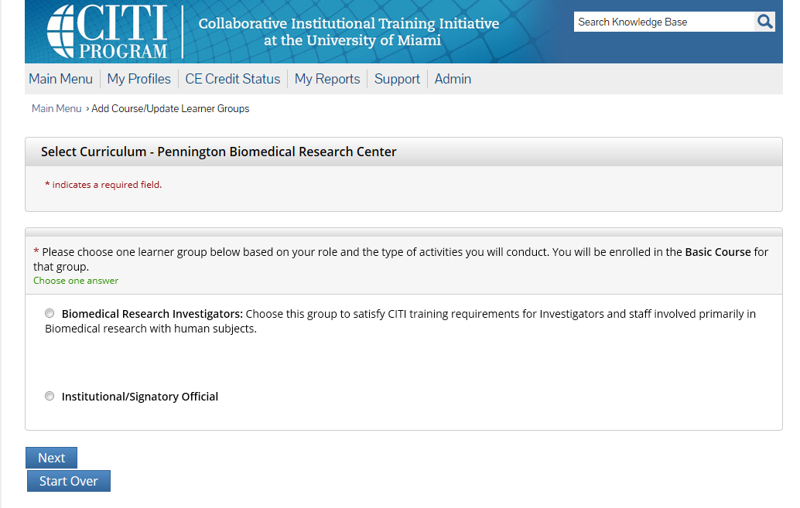

- Please choose “Good Clinical Practice (GCP)”
- Click Next.

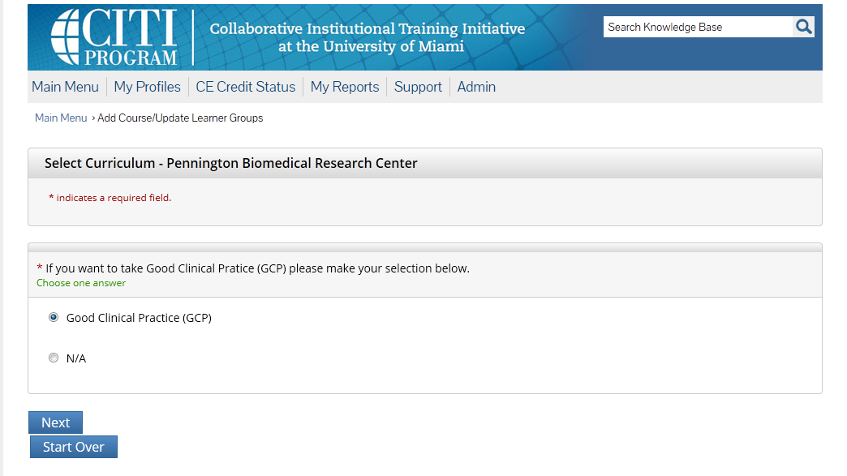

Instructions for Laboratory Animal Training

- In order to satisfy Laboratory Animal Training choose: “Yes, I conduct research or teaching activities that utilizes live, animal subjects or tissues derived from live animal subjects.”
- Click Next.

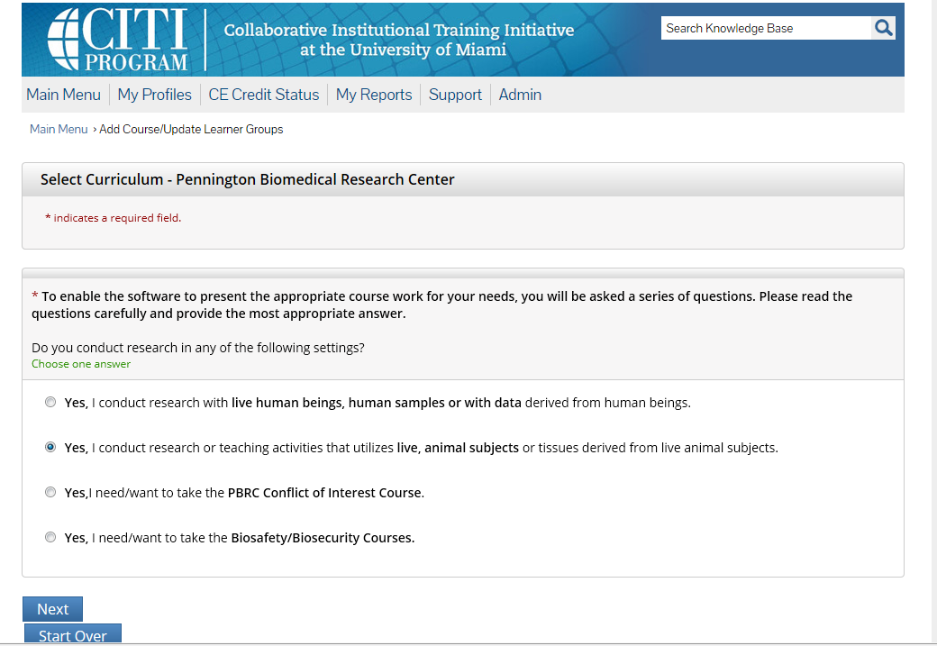

- Select all groups that apply. (Institutional Official applies only if you are the institutional official over Basic Science.)
- Click Next.

